Computer Shop System

Business Use-Case Specification: Manage Comment

Version 1.0

Revision History

|  |  |  |  |
| --- | --- | --- | --- |
| **Date** | **Version** | **Description** | **Author** |
| 22/12/2019 | 1.0 | details | Hoang Trung Hieu |
|  |  |  |  |
|  |  |  |  |
|  |  |  |  |

Table of Contents

1. Introduction 4

1.1 Purpose 4

1.2 Scope 4

1.3 Definitions, Acronyms, and Abbreviations 4

1.4 References 4

1.5 Overview 4

2. Business Use-Case Name 4

2.1 Brief Description 4

3. Goals 4

4. Performance Goals 4

4.1 <name of performance goal> 5

5. Workflow 5

5.1 Basic Workflow 5

5.1.1 <name of workflow step> 5

5.2 Alternative Workflows: Still achieve success but in different way 5

5.2.1 <name of workflow step> 5

6. Risk 5

7. Possibilities 5

8. Process Owner 5

9. Special Requirements 5

9.1 <Name of Special Requirement 1> 5

9.2 <Name of Special Requirement 2> 5

10. Extension Points 6

10.1 <Name of Extension Point> 6

Business Use-Case Specification: Manage Comment

# Introduction

## Purpose

The purpose of this business use-case is to show CT Computer manager manage all of comments’ in Computer Shop

## Scope

The scope of this business use-case is associated with the computer shop to be deployed

## Definitions, Acronyms, and Abbreviations

None

## References

None

## Overview

The rest of the Business Use-case Specification contains goal, risk, process owner and special requirement.

# Business Use-Case Name

## Brief Description

The use case decribes how Computer shop’s manager manages all of the comment of customer in each computer in Computer Shop

# Goals

The goal of the business use-case is helpl to manage all of comment in Computer Shop

# Performance Goals

## <View Comment >

When customer comment in a computer, the comment will display behind the detail of this computer which customer comments. Computer shop manager will check the record in the admin space.

**4.2. <Delete Comment>**

If the comment is be impolite or cause conflicts between other customer. The manager have the right to delete that comment.

# Workflow

When customer comment in a computer, the comment will display behind the detail of this computer which customer comments. Computer shop manager will check the record in the admin space. When having comment in the database, manager need to validate that this comment follow by rules or not . If comment is ok, they will save it incomment daatabase. If comment is not ok, manager will delete comment. And it can be removed from database when this comment is be impolite or cause conflicts between other customer.

## Basic Workflow

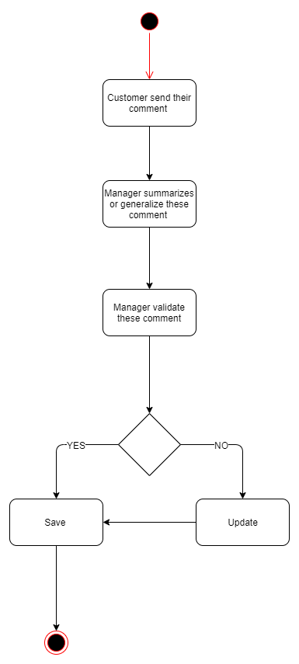

# Risk

No special.

# Possibilities

No special.

# Process Owner

The process owner if this usecase is the administrator or can be called manager of the computer shop who deal with the situation.

# Special Requirements

No special.

# Extension Points

## <No extension Point>